NAP_ALL_THEORY
s m sadman sakib sayor
Table
Question pattern
1. Aggregation, fragmentation, modulation, attenuation, amplification and encapsulation
2. OSI and Hybrid /layered / basic communication –any one
3. CDMA (90% probability) / attenuation db calc
4. compare (ALOHA vs SLOTTED ALOHA) /IEEE802.3 vs IEEE802.5
5. (RANDOM)
6. Protocol data unit of TCP/UDP/Ipv4/Ipv6—any one.

1. Knowing the attenuation (A) is 3 db for ratio p1/p0= 2, calculate and prove without calculator the value of A in db for ratio p2/p0=210! how much p2 in watts? indication: can be approximation 49~50
$$x = 10*log(210)$$
$$or, x = 10*log(10*21)$$
$$or, x = 10log(10) + 10log(21) <log21 \sim log20>$$
$$or, x = 10 + 10log(20)$$
$$or, x = 10 + 10log(2*10)$$
$$or, x = 10 + 10log2 + 10log(10)$$
$$or, x = 10 + 3 + 10$$
x = 23 and p2 is .21 Watts.

2. Knowing the attenuation (A) is 3 db for ratio p1/p0= 2, calculate and prove without calculator the value of A in db for ratio p2/p0=140! how much p2 in watts? indication : can be approximation 49~50
$$x = 10*log(140)$$
$$or, x = 10*log(10*2*7)$$
$$or, x = 10log(10) + 10log(2) +10log(8) <log7 \sim log8>$$
$$or, x = 10 + 10log(2) + 10log(2^3)$$
$$or, x = 10 + 10log(2) + 3*3$$
$$or, x = 10 + 10log2 + 9$$
$$or, x = 10 + 3 + 9$$
x = 22 and p2 is .14 Watts.

3. Explain in detail the following mechanisms: aggregation, fragmentation, modulation, attenuation, amplification and encapsulation

a) Aggregation:
Link aggregation is the combining of multiple network connections in parallel by any method in order to increase throughput (Amount of materials passing through the system) and to provide redundancy in case one link goes down.
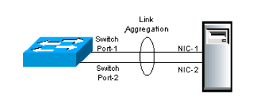

b) Fragmentation:
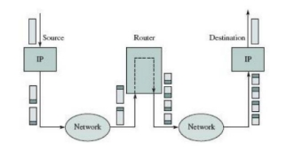
In the layered Network Architecture, a Service Data Unit (SDU) received from a Layer N+1 through the Layer N/N+1 interface has to split into smaller pieces, due to the size limit in Layer N, where each SDU acts as an individual SDU.
C) Modulation: The process of converting data into radio waves by adding information to the Analogue carrier signal, where data transfer channel can be represented as a frequency band, then the digital data is mapped to the analog carrier signal. The amplitude of the analogue carrier signal would then be modified in function of data to become a modulated signal
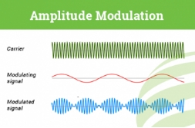

D) Attenuation: Loss of signal strength in Networking cables or connections.
The attenuation depends on the frequency, as the frequency increases, the attenuation also increases. Passive or active repeaters are used in higher distances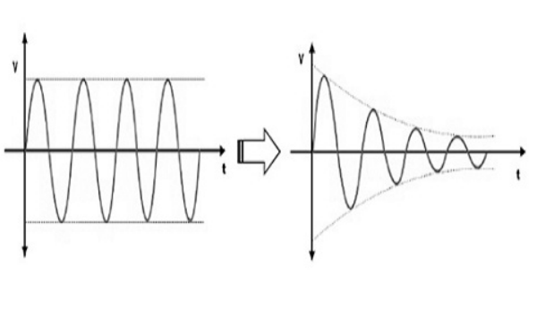

E) Amplification: Boosting the signal in the optical fiber so that it overcomes attenuation. The distance is increased when the data between two sites can be transmitted.
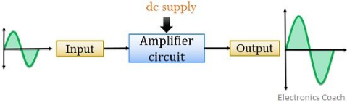

F) Encapsulation: In the layered network architecture, the signal data unit received by a Layer N through the Layer N/N+1 interface is collected with the header and the eventual tail fields obeying the Layer N rules.
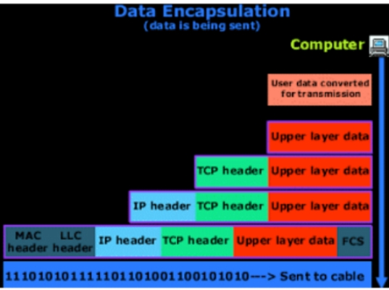

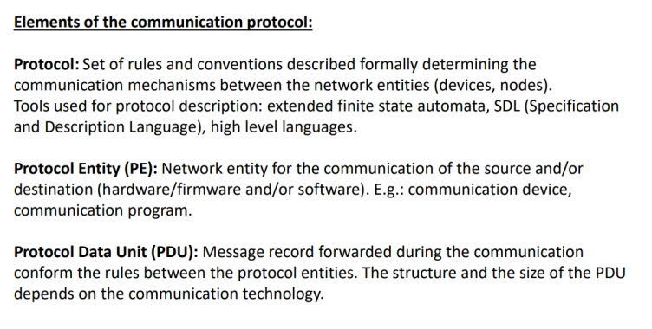
4. Explain in detail the elements and mechanism of the general communication function (text and figure required).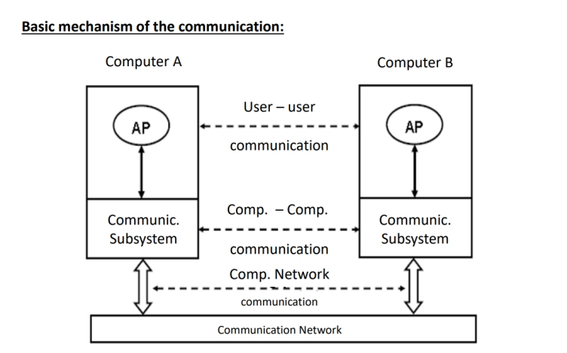

5. Explain in detail the layered network communication model (text and figure required).
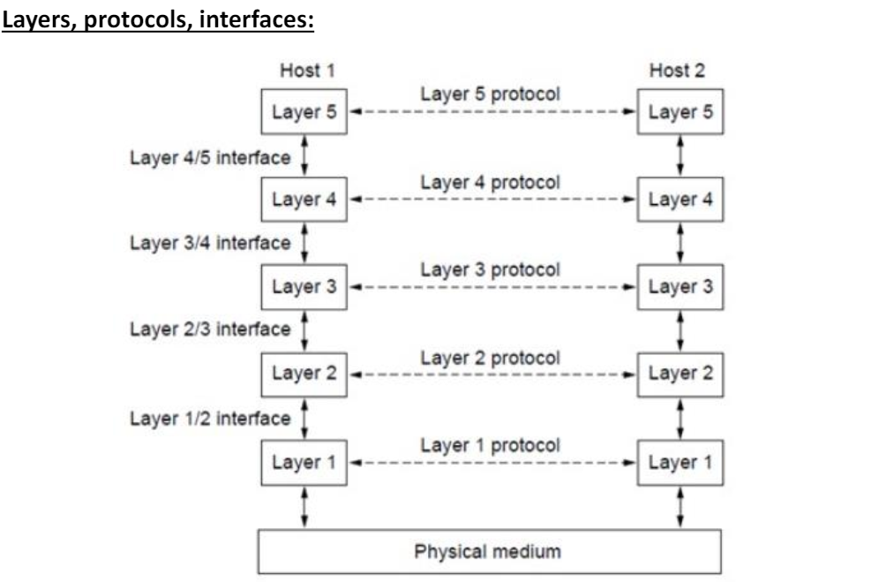
Layer N protocol: Set of communication rules belonging to the logical layer no. N. Peer entities: Communication entities (device/module) of two communication nodes belonging to the same communication layer. Peer entities use the communication protocol of the same logical layer. Protocol Data Unit (PDU): Message transmitted by the peer entities with the layer protocol. Each layer has own PDU format. Layer N/(N+1) interface: Common border of the layer N and layer N+1 on the same communication node. Data and control messages are transmitted through this border. (E.g. formal parameter list) Service Data Unit (SDU): Content transmitted through the layer interface in the same node. Each SDU is specific to the layer interface. Peer entities: Communication entities (device/module) of two communication nodes belonging to the same communication layer. Peer entities use the communication protocol of the same logical layer

6. Explain elements and communication function of the OSI and Hybrid reference model.(text and figure are required.)
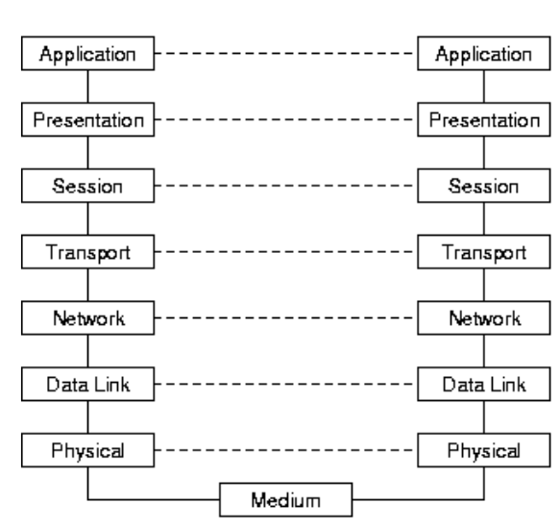
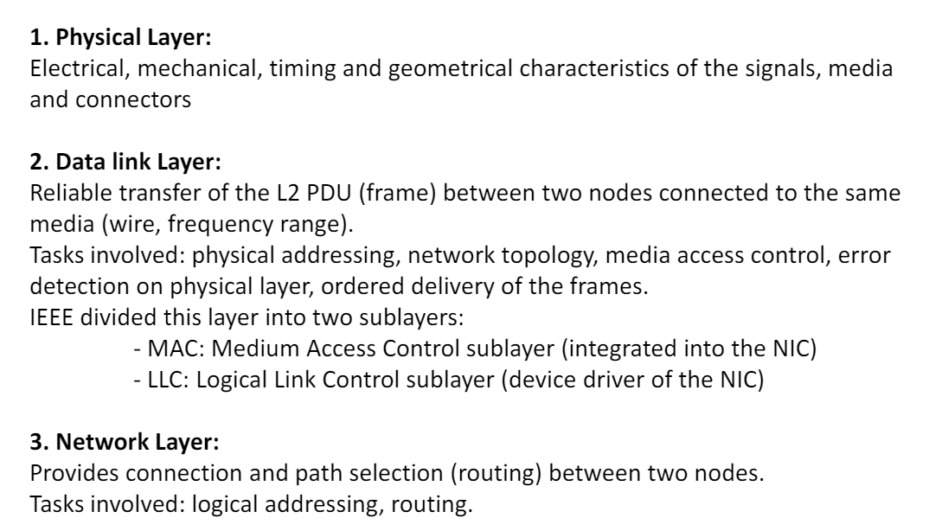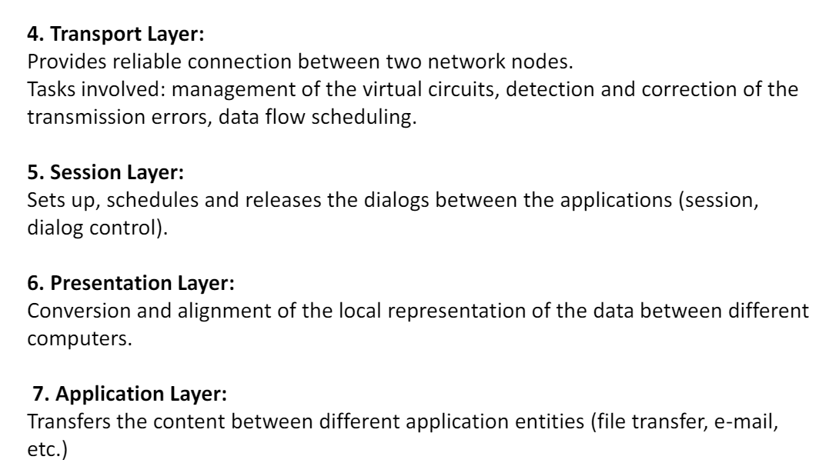

7. CDMA (default question use the same concept below) 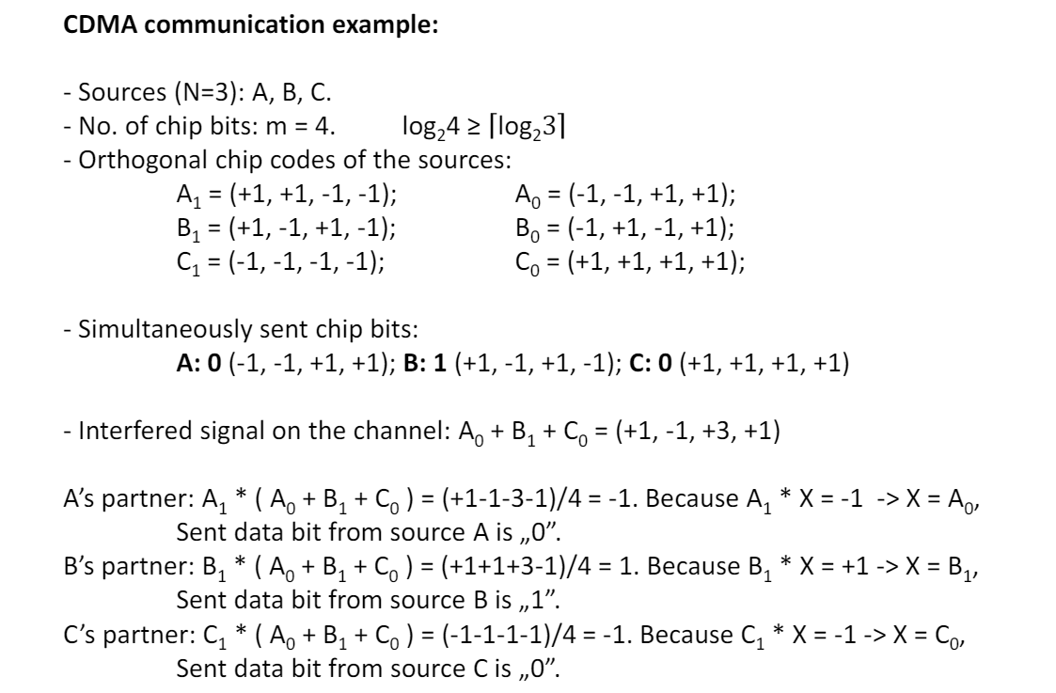

8. Explain in detail the medium access and control mechanism of the IEEE 802.3 technology (text is required).
Medium access control (MAC) sublayer is the layer that controls the hardware responsible for interaction with the transmission medium. The MAC sublayer and the logical link control (LLC) sublayer together make up the data link layer. Within the data link layer, the LLC provides flow control and multiplexing for the logical link, while the MAC provides flow control and multiplexing for the transmission medium.

9. Describe the intermediate node types and their service production in the three lower layers of the communication architecture (text and figure are required).
Network layer: Router
Data link layer: Bridge, switch
Physical layer: repeater, HUB

Router: This device can divide a network, broadcast domain.
It forwards packets.
Each interface segment has unique physical and unique logical address.
Router makes a decision which path is used to send packets.
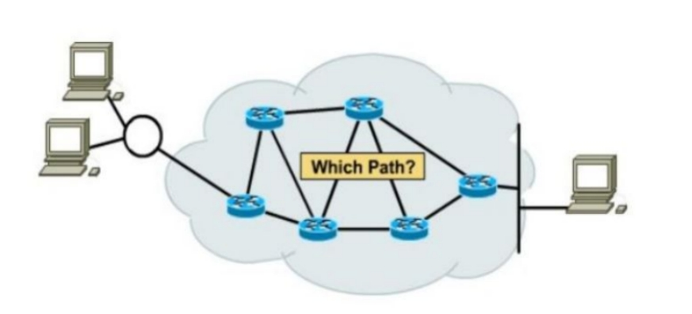
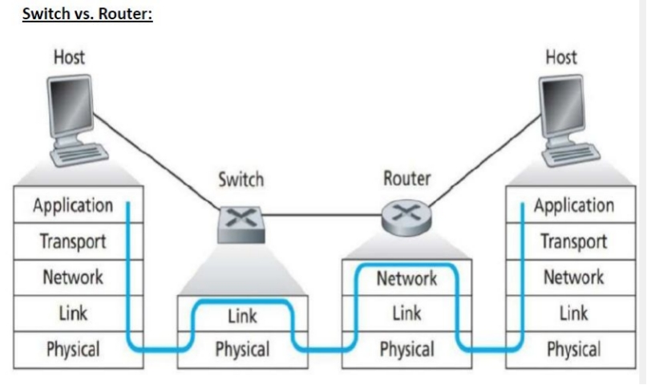
Bridge: This device separates a network and collision domain into segments. Thus, the number of collisions on the network is reduced. Each collision domain has its own separate bandwidth, so a bridge also improves the network performance.
Bridge is not widely used anymore in modern LANs. Switch is commonly used instead.
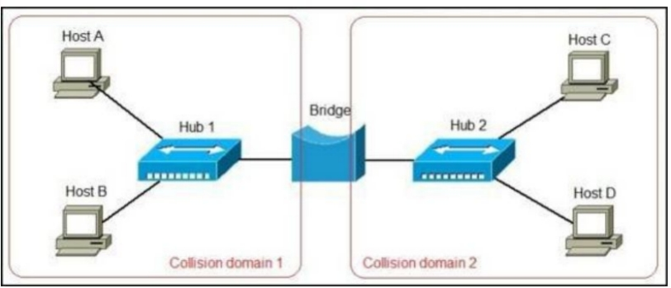
Switch: This device is mainly used for the transfer of the data packets.
In below picture, C and D computers can communicate during communication between A and B (collision does not happen), unlike with hub.
Switch recognizes destination by header of PDU containing source and destination ID.
If transmission has not occurred before, switch cannot recognize destination nodes. Thus, broadcast signal transmission is needed for switch at the first communication so that sender’s port number can be memorized by switch. Then, that port number can be used as a destination port for the next communication.
Switch also has the same function of hub (broadcast signal transmission).
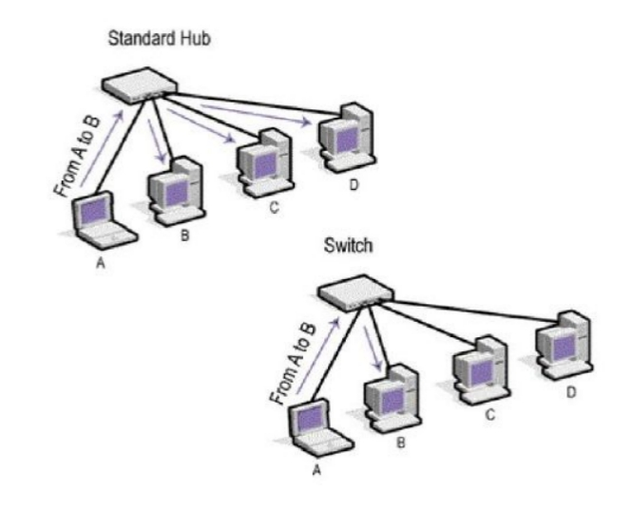
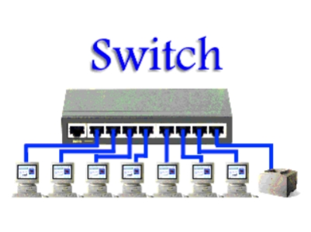

Repeater: The energy of signal may decrease because of distortion of transmission. This device regenerates signal from that corrupted signal. This can receive one signal and regenerate multiple signals.
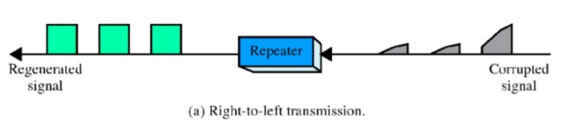
Hub: This device is used to connect segments of a LAN. It contains multiple input/output ports. When signal is at any input port, this signal will be made at all output ports except the one it is coming from (broadcast communication).
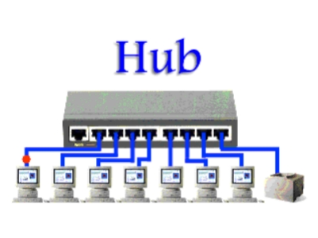

10.Compare and explain the versions of ALOHA communication mechanism (text and figure are required). Prove the efficiency ratio between the variants.
ALOHA can be categorized into two, (pure) ALOHA and slotted ALOHA.

Pure ALOHA:
Pure ALOHA allows stations to transmit whenever they have data to be sent.
When a station sends data, it waits for an acknowledgement.
If the acknowledgement doesn’t come within the allotted time, the station waits for a random amount of time called back-off time (Tb) and re-sends the data.
Since different stations wait for different amount of time, the probability of further collision decreases.
Main advantage is pure ALOHA is easy to implement.
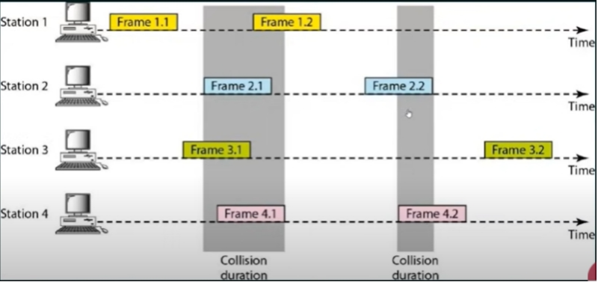

Slotted ALOHA:
Slotted ALOHA was developed to improve the efficiency of pure ALOHA as the chances for collision in pure ALOHA are high.
The time of the shared channel is divided into discrete time intervals called slots.
Sending of data is allowed only at the beginning of these slots.
If a station misses out the allowed time, it must wait for the next slot. This reduces the probability of collision.
Main advantage is slotted ALOHA reduces the number of collisions to half, and doubles the efficiency of pure ALOHA.
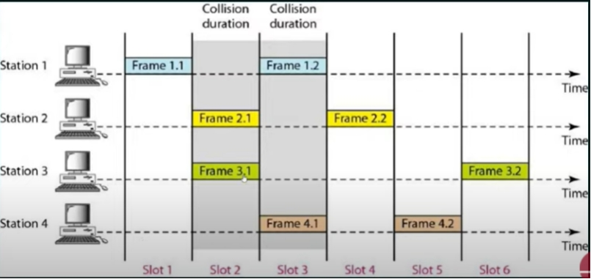
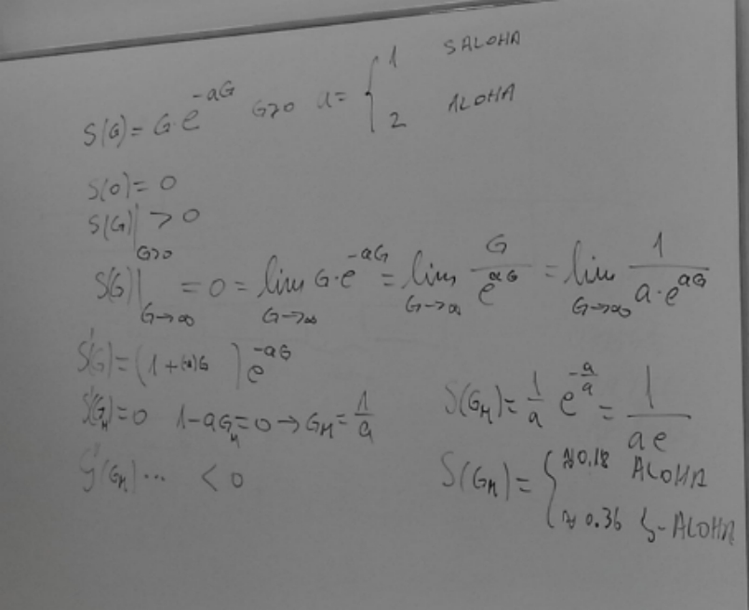

11. Classify and list elements of the routing protocol types used in the internet (text is required).
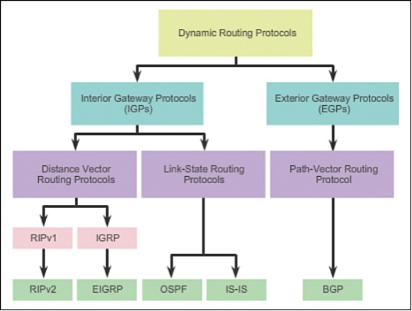
RIP = Routing information protocol
IGRP = Interior gateway routing protocol
EIGRP = Enhanced interior gateway routing protocol
OSPF = Open shortest path first
IS-IS = Immediate system-to-immediate system
BGP = Border gateway protocol
Most routers use dynamic routing.
IGPs are used for routing within an autonomous system (AS).
EGPs are used for routing between AS.
Distance vector routing protocols are advertised by providing two characteristics:
Distance identifies how far it is to the destination network, based on a metric such as the hop count, cost, bandwidth, delay, and more.
Vector specifies the direction of the next-hop router or exit interface to reach the destination.
Link-State routing protocols can create a complete view or topology of the network by gathering information from all of the other routers.
Path-Vector routing protocol maintains the path information that gets updated dynamically.

12. Explain the protocol data unit of the UDP (text is required).
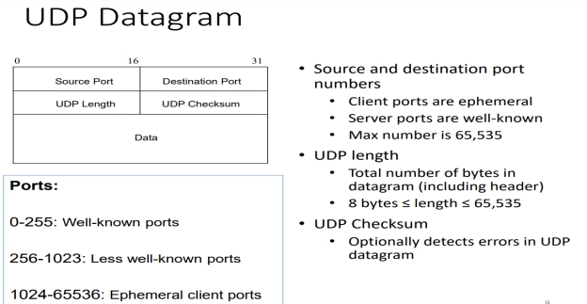

Explanation for header part:
Source port identifies the port sending application.
Destination port identifies the port receiving application.
Length field identifies the combined length of UDP header and encapsulated data.
Length = Length of UDP Header + Length of encapsulated data
Checksum detects error, but it’s not mandatory in UDP.

13. Give five application layer protocols and explain the essence of the service provided (text is required).
- Telnet
Telnet provides bidirectional interactive text orientated communication feature.
- FTP
It stands for File Transfer Protocol. It is used for transforming a file from one location to another.
- TFTP
It stands for Trivial File Transfer Protocol, is used for sending a file from the server to the client.
- SMTP
It stands for Simple mail transfer protocol, is used to transfer the mails. It defines how both commands and responses must be sent back and forth.
- SNMP
It stands for Simple network management protocol, is used to collect and organize the data of managed devices on IP networks. It also modifies the information to change the behavior of the devices.
- DNS
It stands for Domain Name System is a decentralized naming system for the computers and other devices on the internet to translate the domain name of the devices connected on the internet or any other private network to the numerical IP addresses and vice versa.
- DHCP
It stands for Dynamic Host Configuration Protocol. It is a network management protocol present in the application layer. With its help, an Internet Protocol IP address can be assigned to any device or node on a network dynamically so that they can communicate using this IP.

14. Compare IEEE802.3 and IEEE802.5 in the table format.
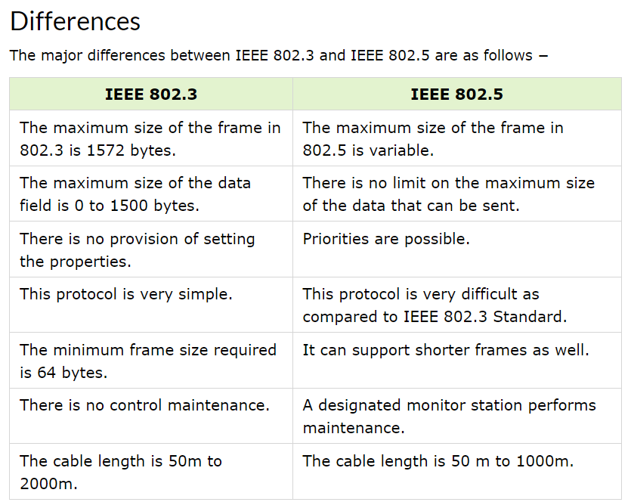

15. Describe function of IGP mechanism (text and figure)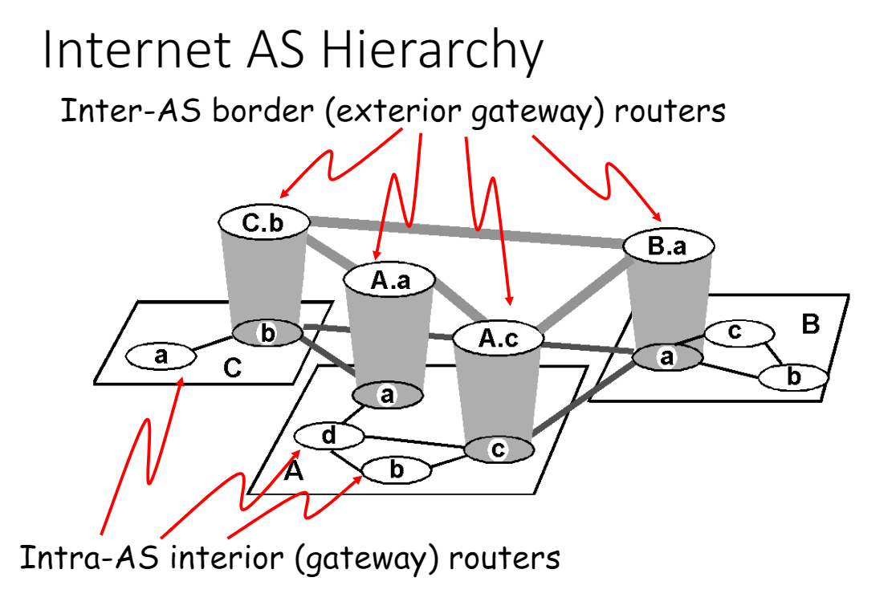 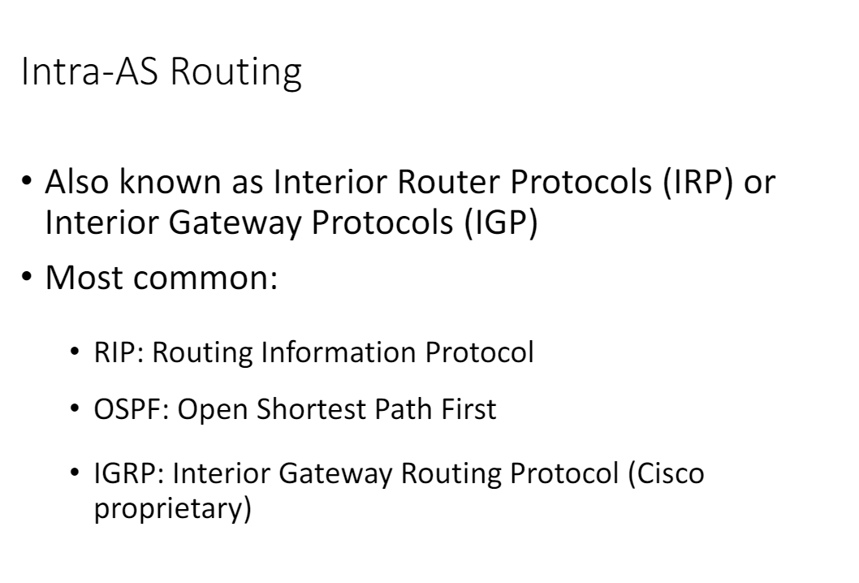

16. Describe addressing mode of ipv4/ipv6 mechanism in details(text and figure)
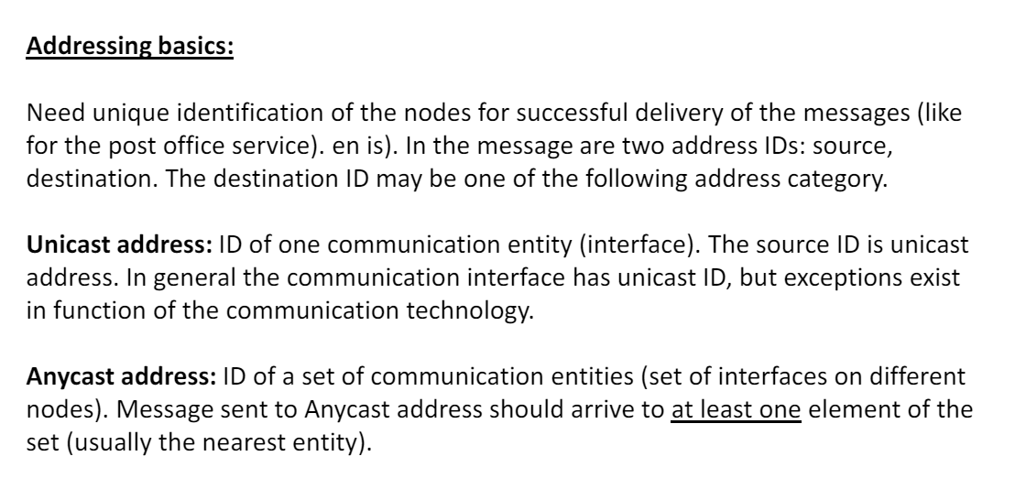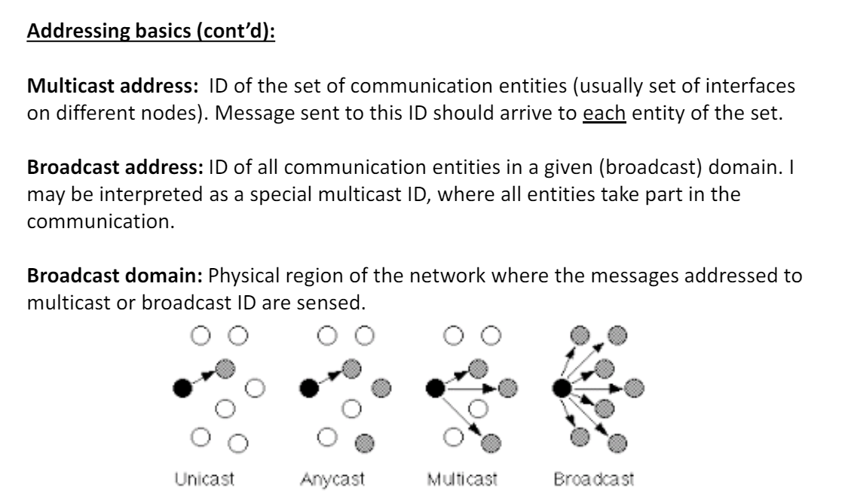

17. Protocol data unit of TCP (text and figure )

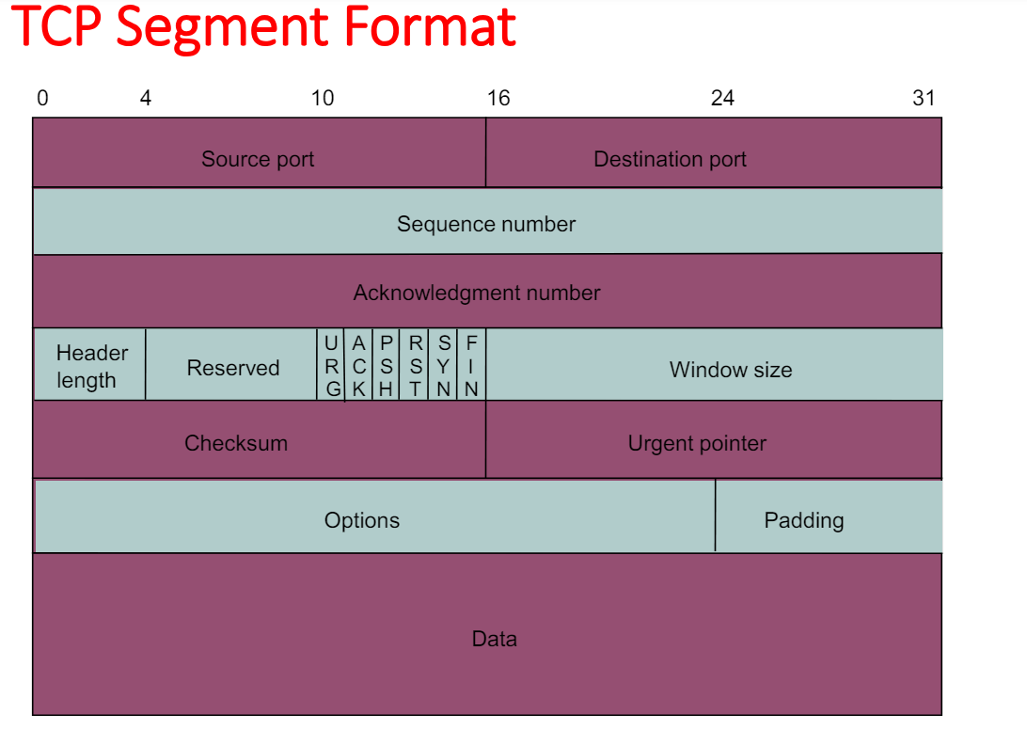
Describe in your own way, he is never gonna read it…

18. Protocol data unit of IPV4. (text and figure)
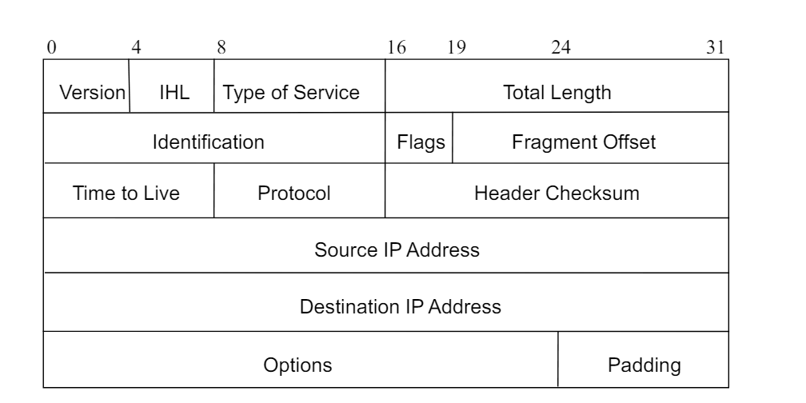
Describe...

19. Protocol data unit of ipv6 mechanism. (text and figure)
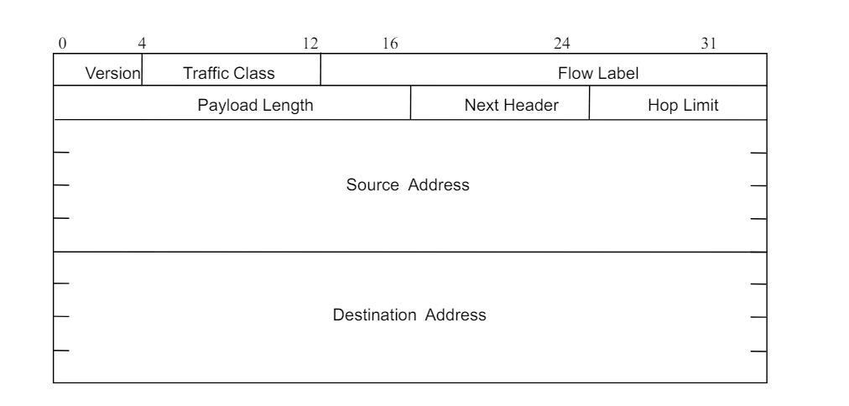

20. Unit of IP in general (text and figure)
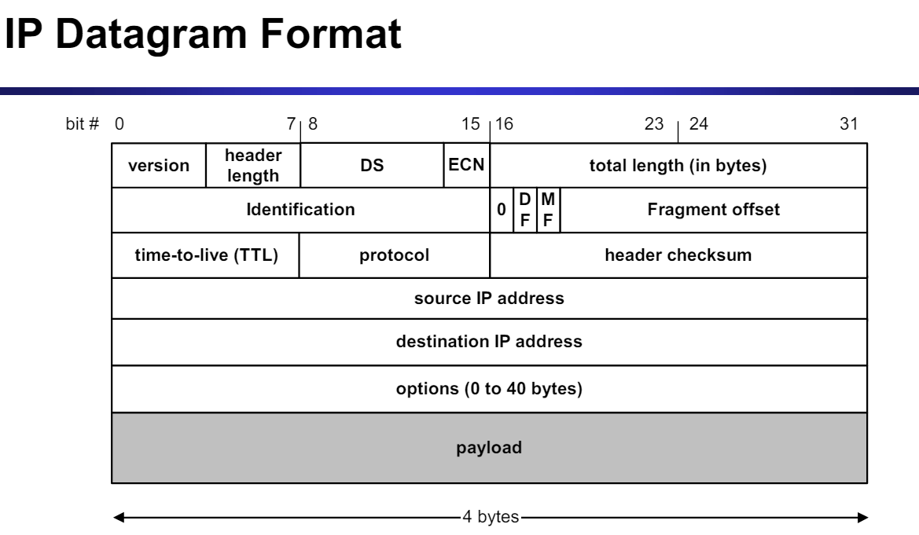
Describe...

